SOP for View Creation in SolarWinds
Creating a Standard Operating Procedure (SOP) for view creation in SolarWinds involves defining a structured process for setting up and customizing views within the platform.
- Access SolarWinds Web Console
  - Log in with administrator credentials.
  - Navigate to the Settings menu.
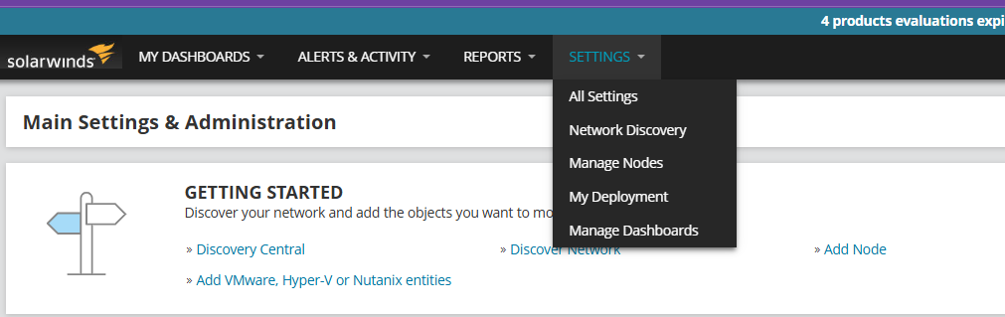
- Create a New View
  - Go to Manage Views under the Main Settings & Administration section.
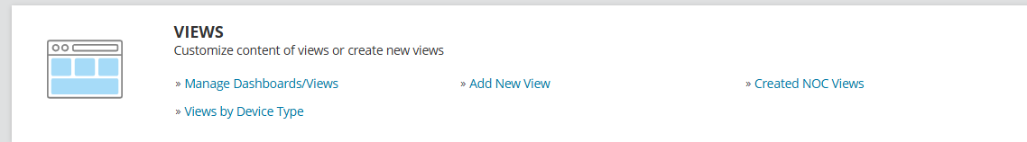
  - Click Add New View and select the appropriate view type (e.g., Summary View, Node Details View).
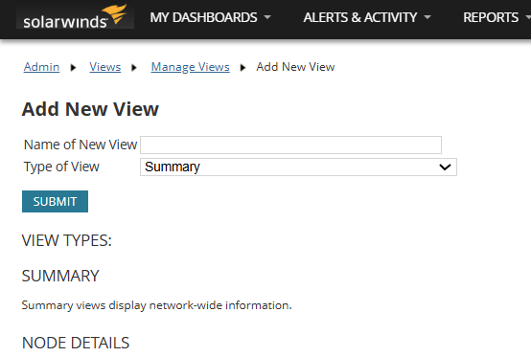

- Customize the View
  - Add widgets such as charts, reports, and alerts.
  - Organize the layout for better visibility.
  - Apply filters to display relevant data.
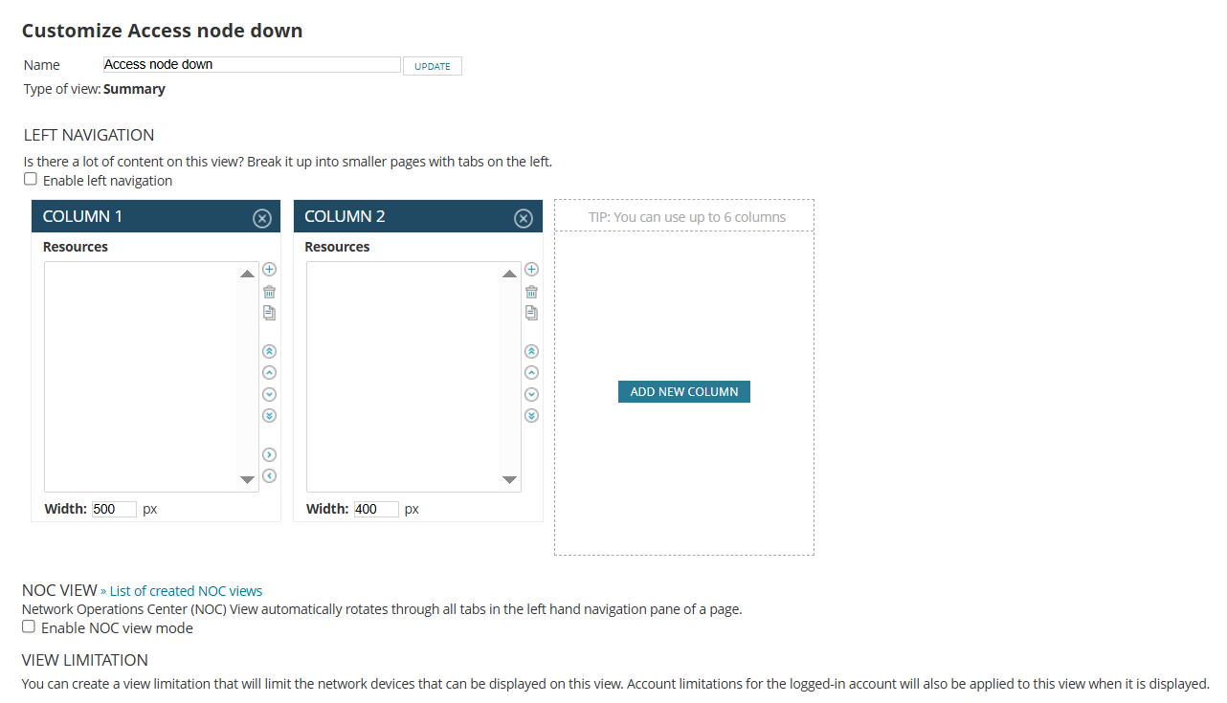
- Assign View Permissions
  - Set administrator rights for managing dashboards.
- Save and Test the View
  - Save the configuration.
  - Verify that the view displays the correct data.
For more detailed, you can check SolarWinds' official documentation on below:
https://documentation.solarwinds.com/en/success_center/npm/content/onboarding/custom_views_maps/core-ob_create_a_view.htm

